Module 4.
Continuous Integration Pipeline

Technical requirements

• Jenkins
• Java JDK 8+

Introducing pipelines
A pipeline is a sequence of automated operations that usually represents a part of the software delivery and quality assurance process. It can be seen as a chain of scripts that provide the following additional benefits:

• Operation grouping: Operations are grouped together into stages (also known as gates or quality gates) that introduce a structure into a process and clearly define a rule – if one stage fails, no further stages are executed.

• Visibility: All aspects of a process are visualized, which helps in quick failure analysis and promotes team collaboration.

• Feedback: Team members learn about problems as soon as they occur so that they can react quickly.

The pipeline structure
A Jenkins pipeline consists of two kinds of elements – a stage and a step. The following diagram shows how they are used:

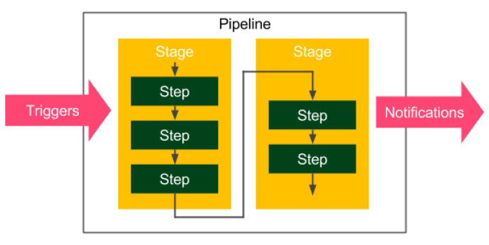

Figure 1 – The Jenkins pipeline structure

The following are the basic pipeline elements:

• Step: A single operation that tells Jenkins what to do – for example, check out code from the repository and execute a script

• Stage: A logical separation of steps that groups conceptually distinct sequences of steps – for example, build, test, and deploy, used to visualize the Jenkins pipeline progress

Information
Technically, it's possible to create parallel steps; however, it's better to treat them as an exception that is only used for optimization purposes.

The pipeline syntax

Sections
Sections define the pipeline structure and usually contain one or more directives or steps.

- Stages: This defines a series of one or more stage directives.

- Steps: This defines a series of one or more step instructions.

- Post: This defines a series of one or more step instructions that are run at the end of the pipeline build; they are marked with a condition (for example, always, success, or failure) and are usually used to send notifications after the pipeline build (we will cover this in detail in the Triggers and notifications section).

- Agent: This specifies where the execution takes place and can define label to match the equally labeled agents, or docker to specify a container that is dynamically provisioned to provide an environment for the pipeline execution.

Directives
Directives express the configuration of a pipeline or its parts:

- Triggers: This defines automated ways to trigger the pipeline and can use cron to set the time-based scheduling, or pollSCM to check the repository for changes.

- Options: This specifies pipeline-specific options – for example, timeout (the maximum time of a pipeline run) or retry (the number of times the pipeline should be rerun after failure).

- Environment: This defines a set of key values used as environment variables during the build.

- Parameters: This defines a list of user-input parameters.

- Stage: This allows for the logical grouping of steps.

- When: This determines whether the stage should be executed, depending on the given condition.

- Tools: This defines the tools to install and put on PATH .

- Input: This allows us to prompt the input parameters.

- Parallel: This allows us to specify stages that are run in parallel.

- Matrix: This allows us to specify combinations of parameters for which the given stages run in parallel.

Steps
Steps are the most fundamental part of the pipeline. They define the operations that are executed, so they actually tell Jenkins what to do:

- sh : This executes the shell command; actually, it's possible to define almost any operation using sh .

- custom : Jenkins offers a lot of operations that can be used as steps (for example, echo ); many of them are simply wrappers over the sh command used for convenience. Plugins can also define their own operations.

- script : This executes a block of Groovy-based code that can be used for some non-trivial scenarios where flow control is needed.

The commit pipeline
The most basic continuous integration process is called a commit pipeline. This classic phase, as its name indicates, starts with commit (or push in Git) to the main repository and results in a report about the build success or failure. Since it runs after each change in the code, the build should take no more than 5 minutes and should consume a reasonable amount of resources. The commit phase is always the starting point of the continuous delivery process and provides the most important feedback cycle in the development process – constant information if the code is in a healthy state.

The commit phase works as follows: a developer checks in the code to the repository, the continuous integration server detects the change, and the build starts. The most fundamental commit pipeline contains three stages:

• Checkout: This stage downloads the source code from the repository.

• Compile: This stage compiles the source code.

• Unit test: This stage runs a suite of unit tests.

Checkout
Checking out code from the repository is always the first operation in any pipeline. In order to see this, we need to have a repository. Then, we are able to create a pipeline.

Creating a GitHub repository

Creating a checkout stage

Compile

In order to compile a project, we need to do the following:

1. Create a project with the source code.
2. Push it to the repository.
3. Add the Compile stage to the pipeline.

Pushing code to GitHub

Creating a Compile stage
We can add a Compile stage to the pipeline.

Unit tests

Writing a unit test
We already have the working application. How can we ensure that the logic works as expected?

Creating a Unit test stage
Now, we can add a Unit test stage to the pipeline:

Code-quality stages
We can extend the three classic steps of continuous integration with additional steps. The most popular are code coverage and static analysis.

Code coverage
Think about the following scenario: you have a well-configured continuous integration process; however, nobody in your project writes unit tests. It passes all the builds, but it doesn't mean that the code is working as expected. What do we do then? How do we ensure that the code is tested?

The solution is to add a code coverage tool that runs all tests and verifies which parts of the code have been executed. Then, it can create a report that shows the untested sections.
Moreover, we can make the build fail when there is too much untested code.
There are a lot of tools available to perform the test coverage analysis; for Java, the most popular are JaCoCo, OpenClover, and Cobertura.

Let's use JaCoCo and show how the coverage check works. In order to do this, we need to perform the following steps:

1. Add JaCoCo to the Gradle configuration.
2. Add the code coverage stage to the pipeline.
3. Optionally, publish JaCoCo reports in Jenkins.

Static code analysis
Your code coverage may work perfectly fine; however, what about the quality of the code itself? How do we ensure it is maintainable and written in a good style?

Static code analysis is an automatic process of checking code without actually executing it. In most cases, it implies checking a number of rules on the source code. These rules may apply to a wide range of aspects; for example, all public classes need to have a Javadoc comment, the maximum length of a line is 120 characters, or if a class defines the equals() method, it has to define the hashCode() method as well.

The most popular tools to perform static analysis on Java code are Checkstyle, FindBugs, and PMD. Let's look at an example and add the static code analysis stage using Checkstyle.

We will do this in three steps:

1. Adding the Checkstyle configuration
2. Adding the Checkstyle stage
3. Optionally, publishing the Checkstyle report in Jenkins

SonarQube
SonarQube is the most widespread source code quality management tool.
It supports multiple programming languages and can be treated as an alternative to the code coverage and static code analysis steps we looked at. Actually, it is a separate server that aggregates different code analysis frameworks, such as Checkstyle, FindBugs, and JaCoCo. It has its own dashboards and integrates well with Jenkins.

Triggers and notifications
So far, we have always built the pipeline manually by clicking on the Build Now button.
It works completely fine but may not be very convenient in practice. All team members would have to remember that after committing to the repository, they need to open Jenkins and start the build. The same applies to pipeline monitoring; so far, we have manually opened Jenkins and checked the build status.

Triggers
An automatic action to start the build is called the pipeline trigger. In Jenkins, there are many options to choose from; however, they all boil down to three types:

• External
• Polling Source Control Management (SCM)
• A scheduled build

External
External triggers are easy to understand. They mean that Jenkins starts the build after it's called by the notifier, which can be the other pipeline build, the SCM system (for example, GitHub), or any remote script.

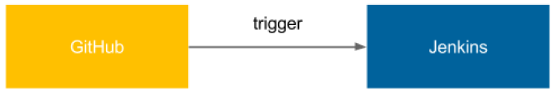

Figure 2 – An external trigger

To configure the system this way, we need the following setup steps:

1. Install the GitHub plugin in Jenkins.
2. Generate a secret key for Jenkins.
3. Set the GitHub webhook and specify the Jenkins address and key.

Polling SCM

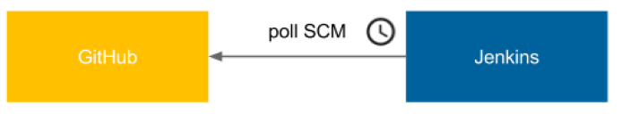

Figure 3 – Polling the SCM trigger

Jenkins periodically calls GitHub and checks whether there was any push to the repository. Then, it starts the build. It may sound counter-intuitive, but there are at least two good cases for using this method:

• Jenkins is inside the firewalled network (which GitHub does not have access to).
• Commits are frequent and the build takes a long time, so executing a build after every commit would cause an overload.

Scheduled builds
The scheduled trigger means that Jenkins runs the build periodically, regardless of whether there were any commits to the repository.


Figure 4 – The scheduled build trigger

The implementation of Scheduled build is exactly the same as polling SCM. The only difference is that the cron keyword is used instead of pollSCM.

Notifications
Jenkins provides a lot of ways to announce its build status. What's more, as with everything in Jenkins, new notification types can be added using plugins.

Email
The most classic way to notify users about the Jenkins build status is to send emails. The advantage of this solution is that everybody has a mailbox, everybody knows how to use it, and everybody is used to receiving information in it.

The configuration of the email notification is very simple:

1. Have the SMTP (Simple Mail Transfer Protocol) server configured.
2. Set its details in Jenkins (in Manage Jenkins | Configure System).
3. Use the mail to instruction in the pipeline.

The pipeline configuration can be as follows:

post {
always {
mail to: 'team@company.com',
subject: "Completed Pipeline: ${currentBuild.fullDisplayName}",
body: "Your build completed, please check: ${env.
BUILD_URL}"
}
}

Note that all notifications are usually called in the post section of the pipeline, which is executed after all steps, no matter whether the build succeeded or failed. We used the always keyword; however, there are different options:

- always: Execute regardless of the completion status.

- changed: Execute only if the pipeline changed its status.

- fixed: Execute only if the pipeline changed its status from failed to success.

- regression: Execute only if the pipeline changed its status from success to failed, unstable, or aborted.

- aborted: Execute only if the pipeline was manually aborted.

- failure: Execute only if the pipeline has the failed status.

- success: Execute only if the pipeline has the success status.

- unstable: Execute only if the pipeline has the unstable status (usually caused by test failures or code violations).

- unsuccessful: Execute only if the pipeline has any status other than success.

